PROJECT REPORT 2

WEATHER APP

NAME- ANANYA ARORA

REGISTRATION NO- 20BCB0031

GITHUB LINK-<https://github.com/ananya5254/WeatherApp/tree/main>

ROLE- INDIVIDUAL PROJECT

LEARNING- ANDROID STUDIO,VARIOUS LAYOUTS,IMAGE VIEW ,ANDROID PERMISSIONS ,USE OF JSON DATA AND USE OF APIs.

COURSES- I TOOK REFERENCES FROM YOUTUBE VIDEOS,WEBSITES LIKE GEEKSFORGEEKS

LIBRARIES –

* ANDROID STUDIO
* API KEY AND URL FROM Openweathermap

WORKFLOW OF THE PROJECT-

FRONT SCREEN OF THE PROJECT SHOWS THE TEMPERATURE OF THE CURRENT LOCATION OF USER ALSO CONTAIN SEARCH BUTTON TO SEARCH TEMPERATURE OF OTHER CITY.

AFTER CLICKING THE SEARCH OPTION THE TEXT BOX ASKS FOR CITY NAME

AFTER CLICKING THE ENTER KEY THE TEMPERATURE OF SEARCHED CITY IS SHOWN

SCREENSHOTS-

FRONT SCREEN (CURRENT)

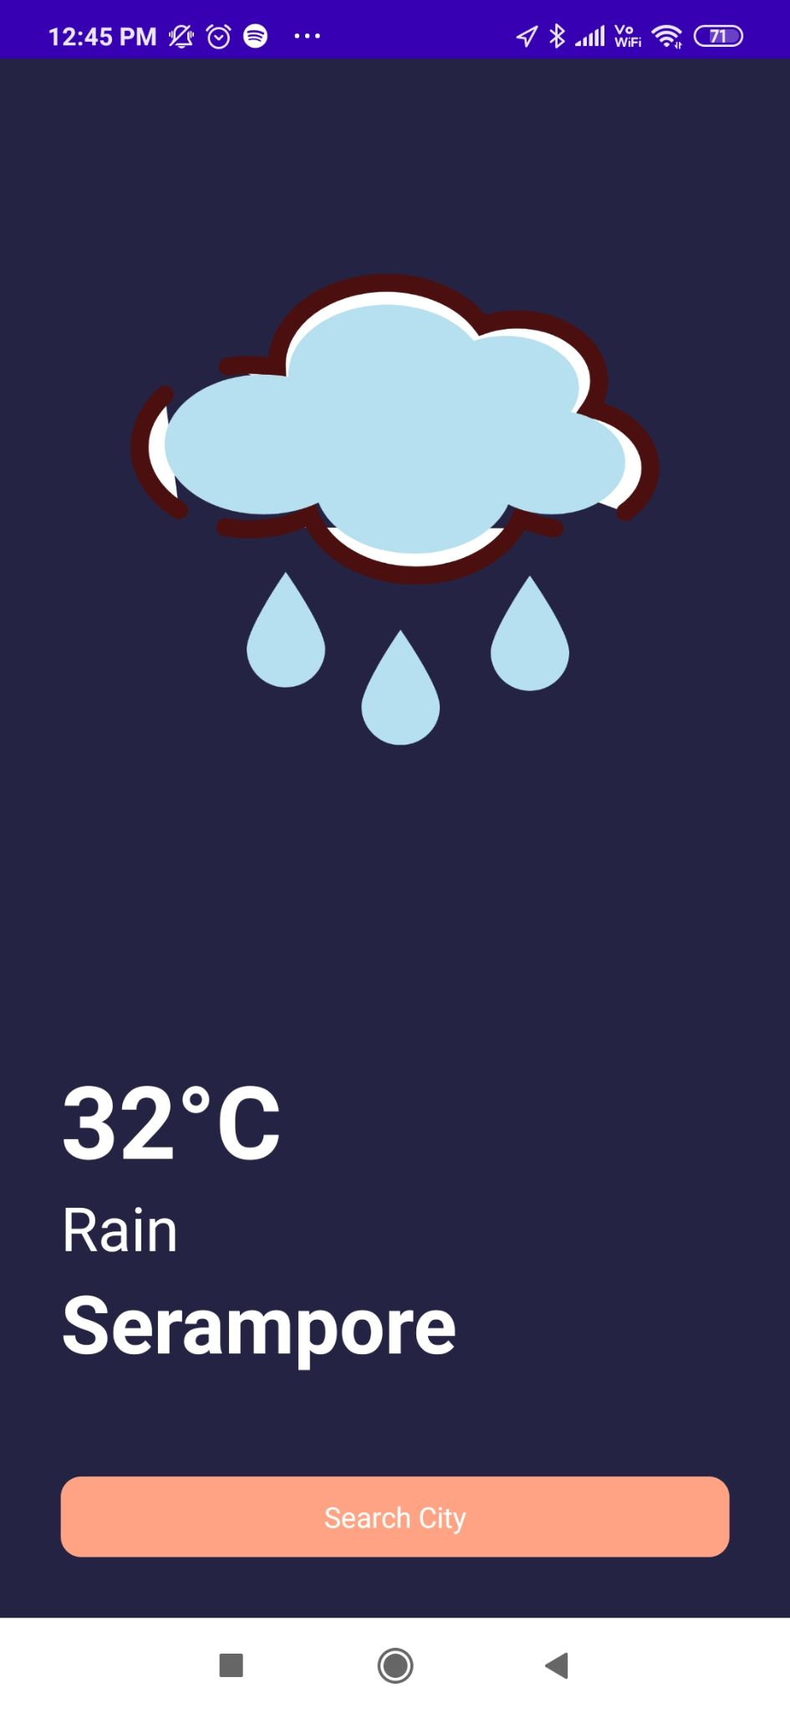

AFTER CLICKING SEARCH

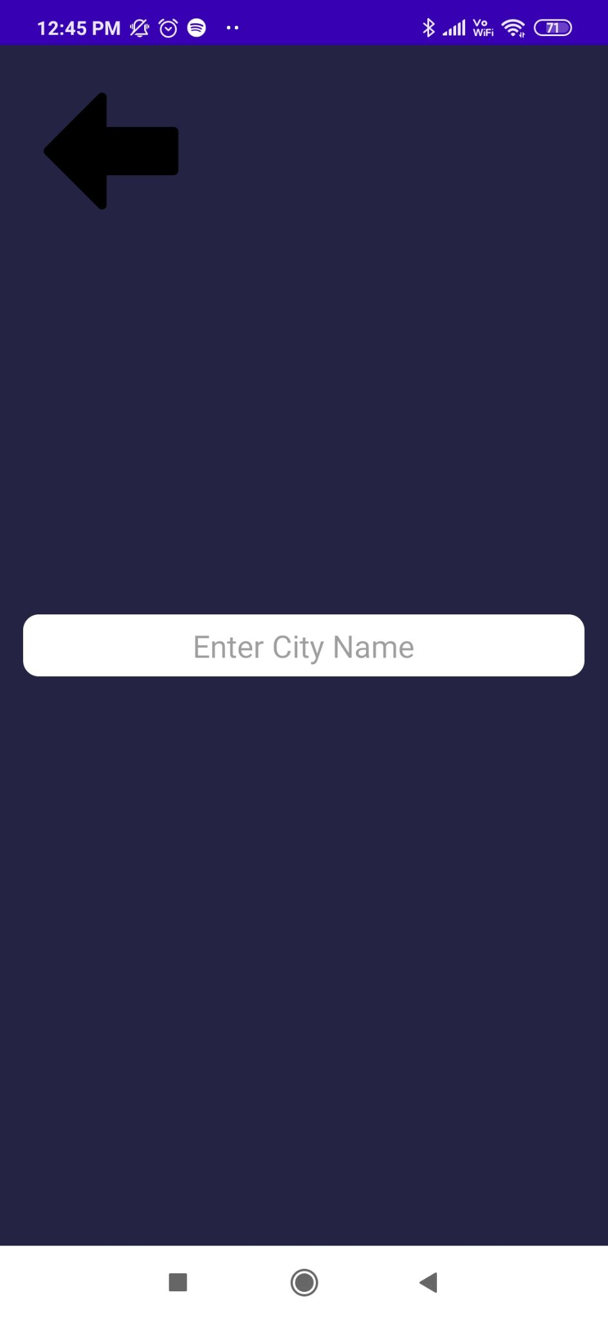

SEARCHING MUMBAI

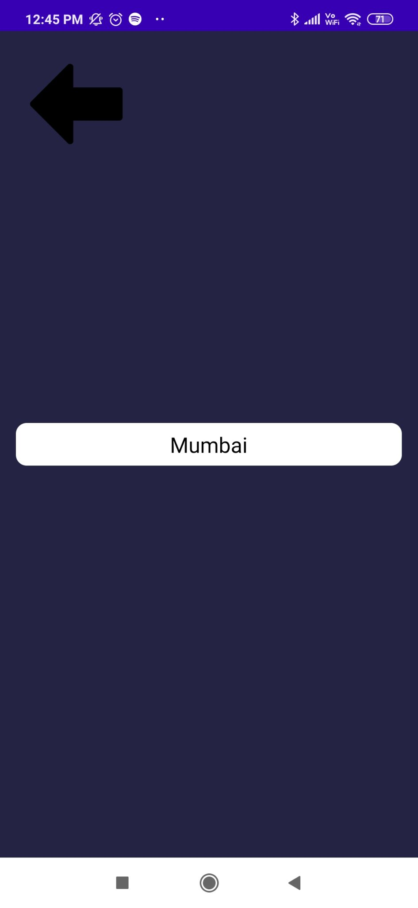

TEMPERATURE OF MUMBAI

